Given two arrays of positive integers boxes and warehouse representing the heights of some boxes of unit width, and the heights of n rooms in a warehouse, respectively. The warehouse's rooms are labeled from 0 to n - 1 from left to right where warehouse[i] (0-indexed) is the height of the ith room.

Boxes are put into the warehouse by the following rules:

* Boxes can't be piled up.
* You can rearrange the order of the boxes.
* Boxes can only be pushed into the warehouse from left to right only.
* If the height of some room in the warehouse is less than the height of a box, then the box will be stopped before that room, so are the boxes behind it.

Return *the maximum number of boxes you can put into the warehouse.*

**Example 1:**

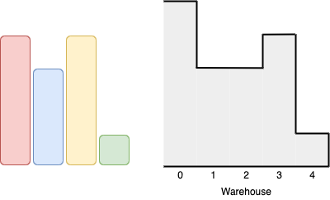

**Input:** boxes = [4,3,4,1], warehouse = [5,3,3,4,1]

**Output:** 3

**Explanation:**

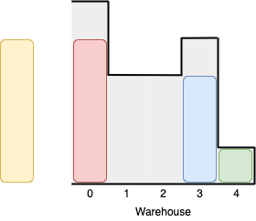

We can first put the box of height 1 in room 4. Then we can put the box of height 3 in either of the 3 rooms 1, 2, or 3. Lastly, we can put one box of height 4 in room 0.

There is no way we can fit all 4 boxes in the warehouse.

**Example 2:**

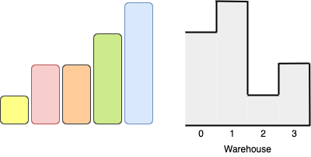

**Input:** boxes = [1,2,2,3,4], warehouse = [3,4,1,2]

**Output:** 3

**Explanation:**

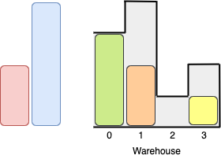

Notice that it's not possible to put the box of height 4 into the warehouse since it cannot pass the first room of height 3.

Also, for the last two rooms, 2 and 3, only boxes of height 1 can fit.

We can fit 3 boxes maximum as shown above. The yellow box can also be put in room 2 instead.

Swapping the orange and green boxes is also valid, or swapping one of them with the red box.

**Example 3:**

**Input:** boxes = [1,2,3], warehouse = [1,2,3,4]

**Output:** 1

**Explanation:** Since the first room in the warehouse is of height 1, we can only put boxes of height 1.

**Example 4:**

**Input:** boxes = [4,5,6], warehouse = [3,3,3,3,3]

**Output:** 0

**Constraints:**

* n == warehouse.length
* 1 <= boxes.length, warehouse.length <= 10^5
* 1 <= boxes[i], warehouse[i] <= 10^9